Holiday Santa Rita Dinner

And

 The Food Truck Round-up 

Present:

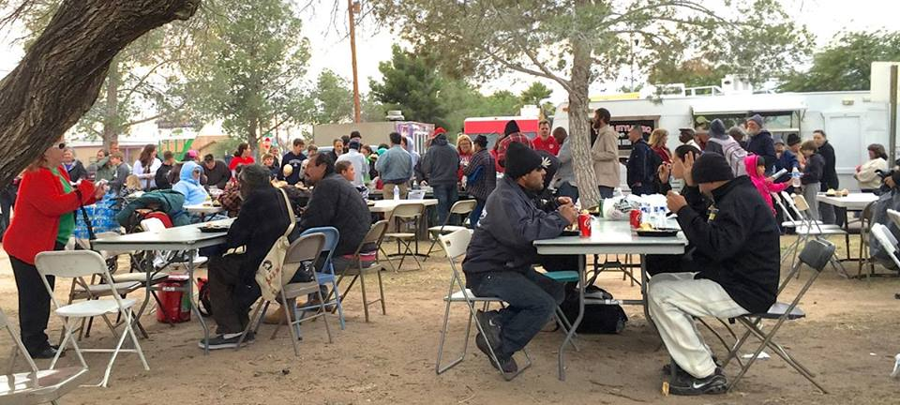

Our 3rd Annual Christmas Dinner

in Santa Rita Park

22nd St. and 3rd Ave.

December 25, 2016 at 3:00 p.m.

Volunteer to help, or come to enjoy a FREE hot turkey dinner, gifts from Santa, and a selection of gently used warm clothing.